**HOW TO CREATE AN ACCOUNT TO PATENT MONETIZE**

**Step 1. Go to patentmonetize.com and click login to create an account.**

Step 1: Visit patentmonetize.com and click on "Login" to create an account.



**Step 2. Here is a form to create an account.**

Step 2: Fill out the form provided to create your account.

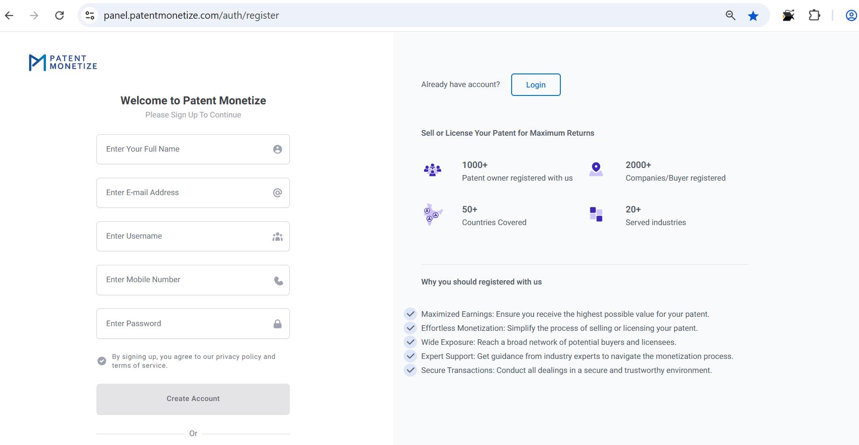

**Step 3. After filing form click create account.**

Step 3: After filling out the form, click "Create Account" to complete the registration.

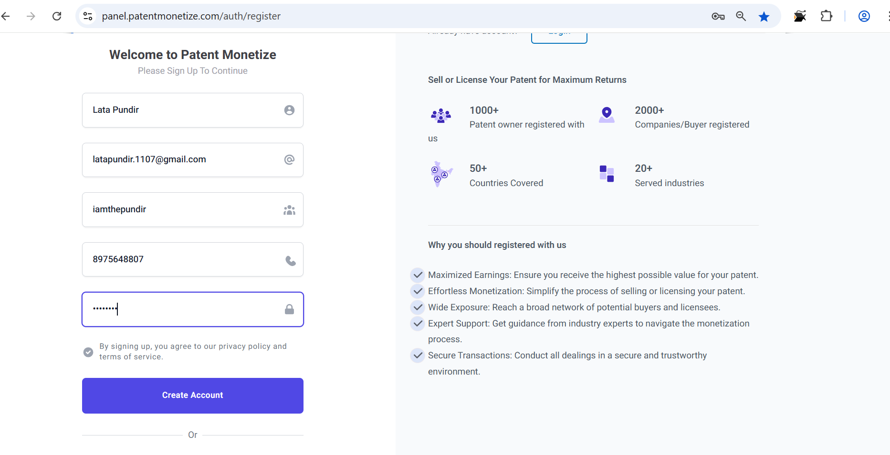

**Step 4. Check Email and Click Verify Email Address**

Step 4: Check your email and click "Verify Email Address" to complete the verification process.

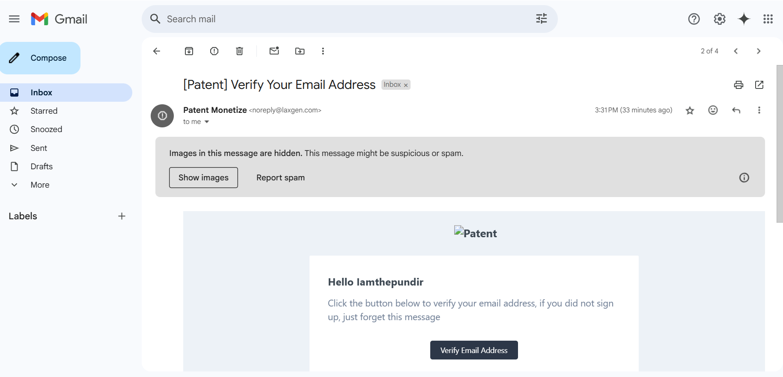

**Your Account successfully created once you click to verify the email.**

Your account will be successfully created once you click the "Verify Email Address" link.

**HOW TO LIST YOURSELF AS A BUYER**

**Step 1. Go to patentmonetize.com and click login with your email id and password.**

Step 1: Go to patentmonetize.com and click "Login" using your email ID and password.

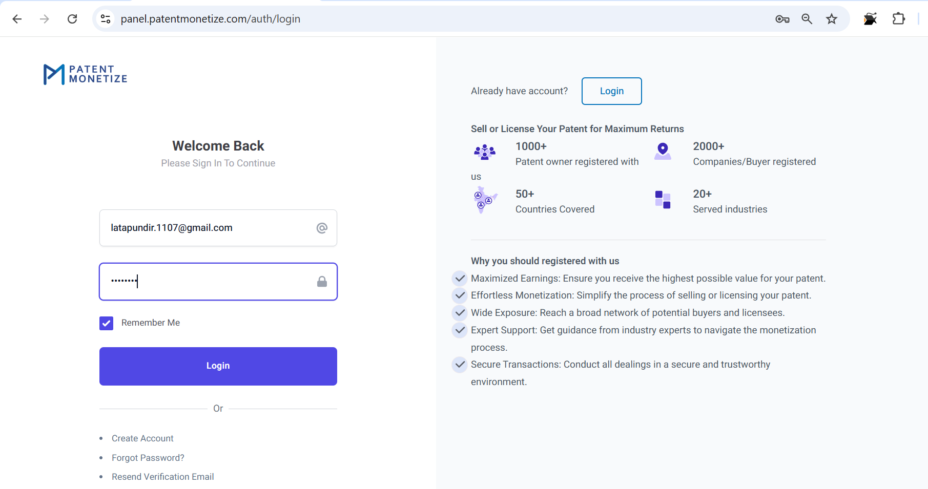

**Step 2. Fill the form to become a buyer.**

Step 2: Fill out the form to register as a buyer.

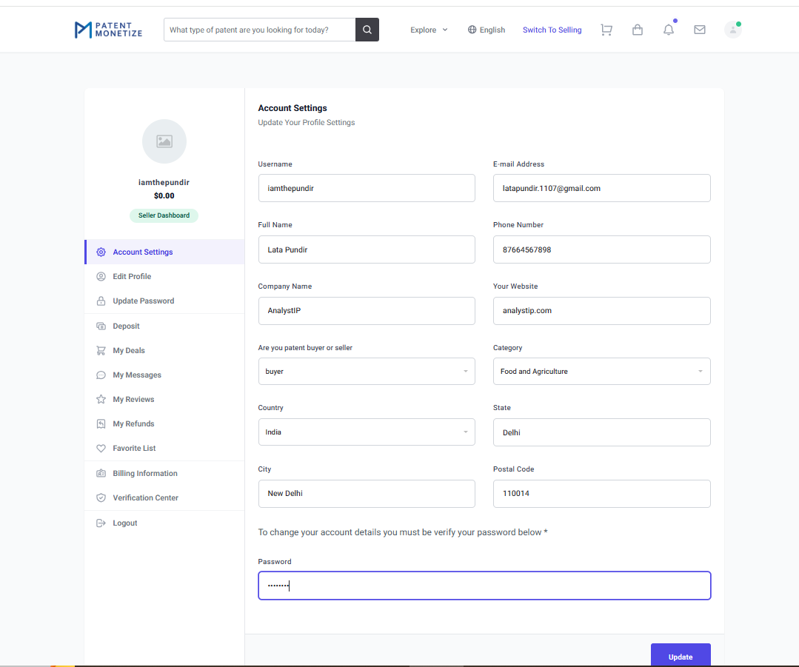

**Now you have listed a buyer successfully.**

Now, you have successfully listed as a buyer.

**Now you can explore the listed patents on the platform. Also, get the automatic notification once your require category patent will be listed.**

You can now explore the listed patents on the platform and will receive automatic notifications from us once patents of your category will be listed.

**"HOW TO LIST YOURSELF AS A PATENT SELLER: A STEP-BY-STEP GUIDE"**

**Step 1. Go to patentmonetize.com and click login with your email id and password in the left side of website there is option to become a seller.**

Step 1: Go to patentmonetize.com and click "Login" with your email ID and password. On the left side of the website, there is an option to "Become a Seller."

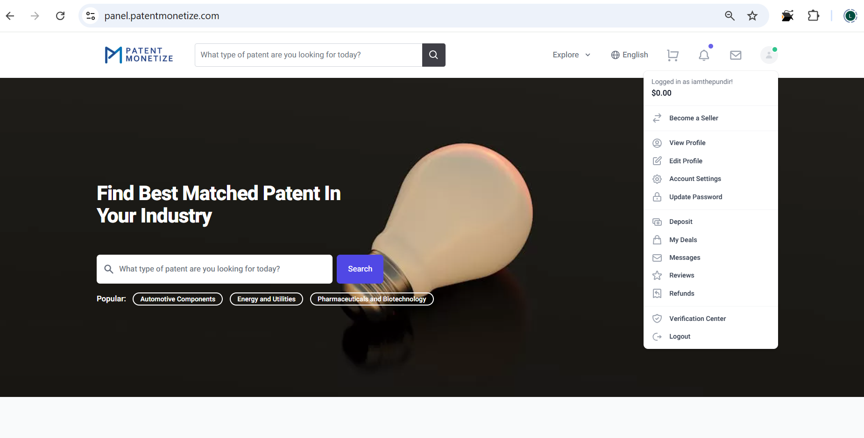

**Step 2. Once you click to become a seller, you get the below option to monetize your invention.**

Step 2: Once you click "Become a Seller," you will be presented with options to monetize your invention.

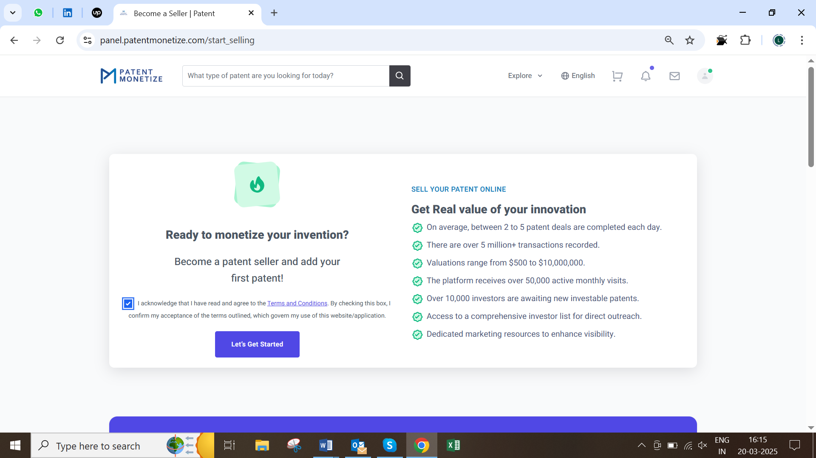

**Step 3. Once you click to let’s get started, you get the blue box of left side to list new patent.**

Step 3: Once you click "Let's Get Started," a blue box will appear on the left side, allowing you to list a new patent.

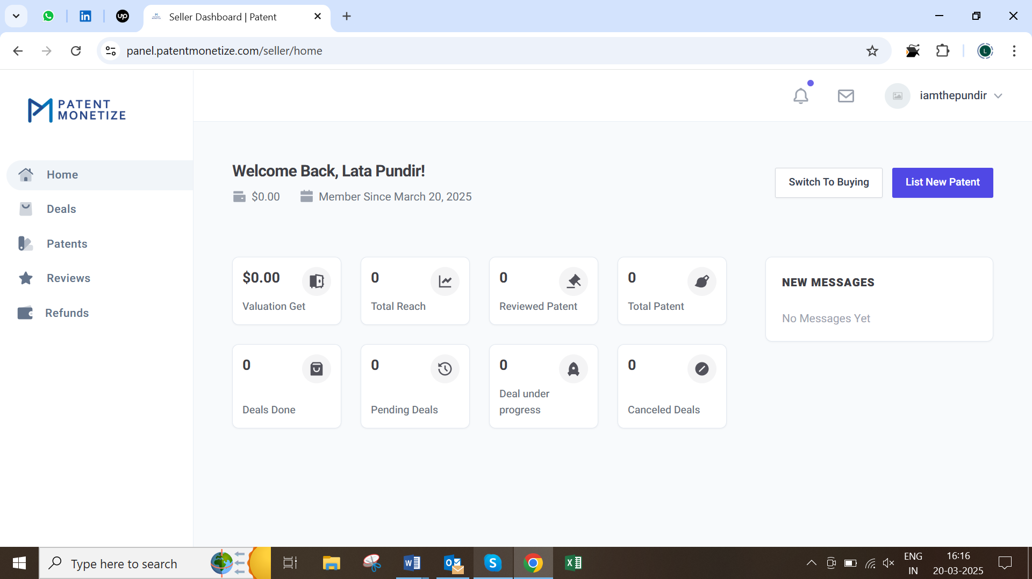

**Step 4. Here is the 4 steps to list your patent, go to step by step.**

Step 4: To list your patent, follow the 4 steps outlined, going through each step one by one.

**There are option to list a single patent or create a patent portfolio for sale, license, and both.**

You have the option to list a single patent or create a patent portfolio for sale, license, or both.

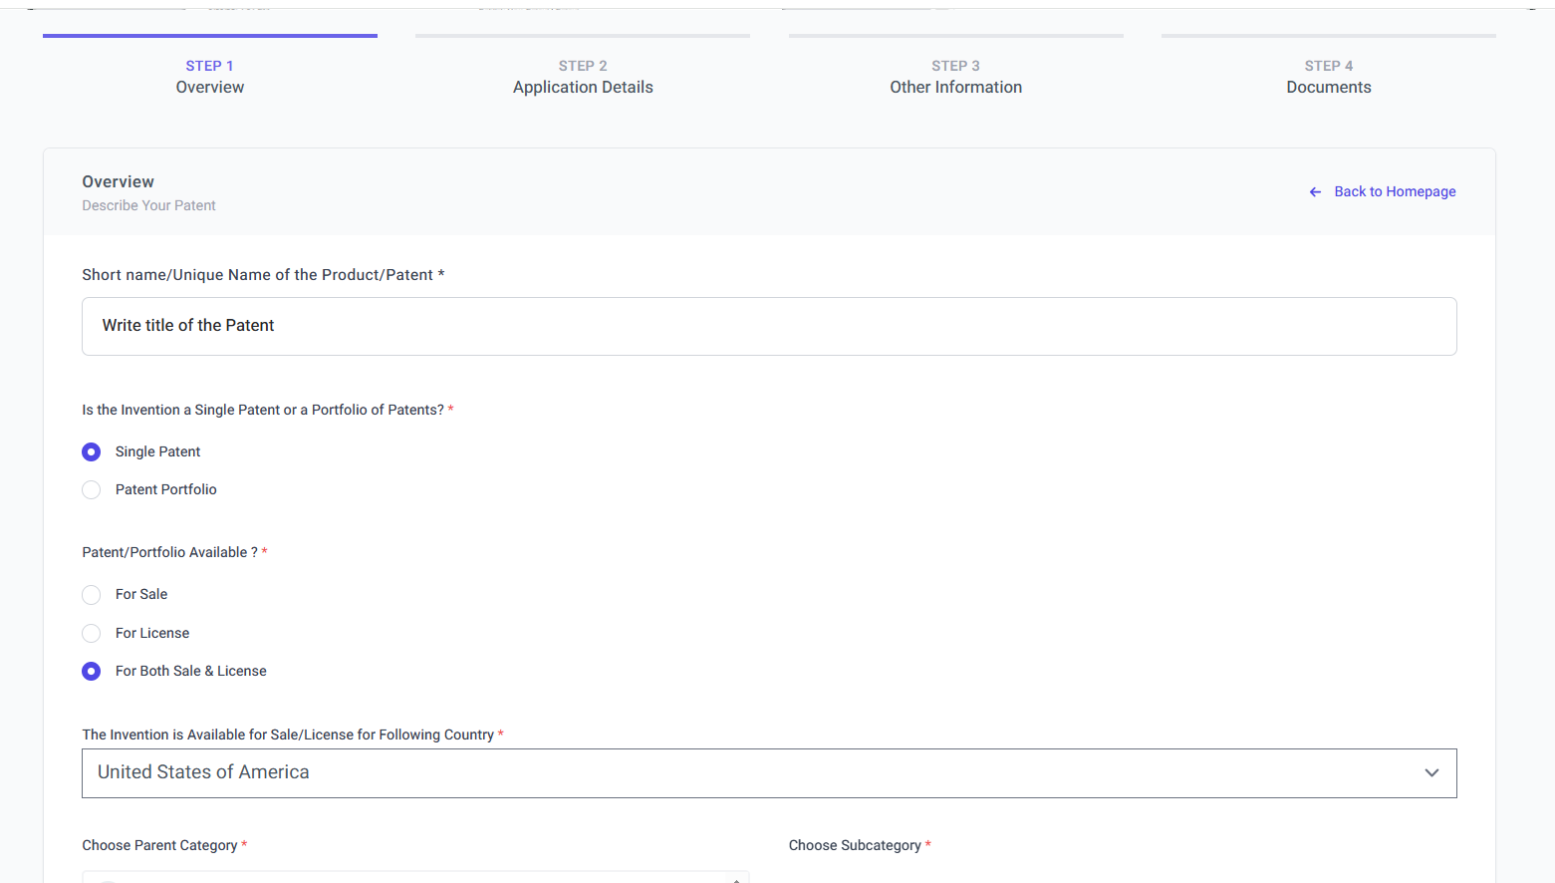

**Here is the option of countries, patent category and subcategory.**

Here, you'll find options to select the countries, patent category, and subcategory for your listing.

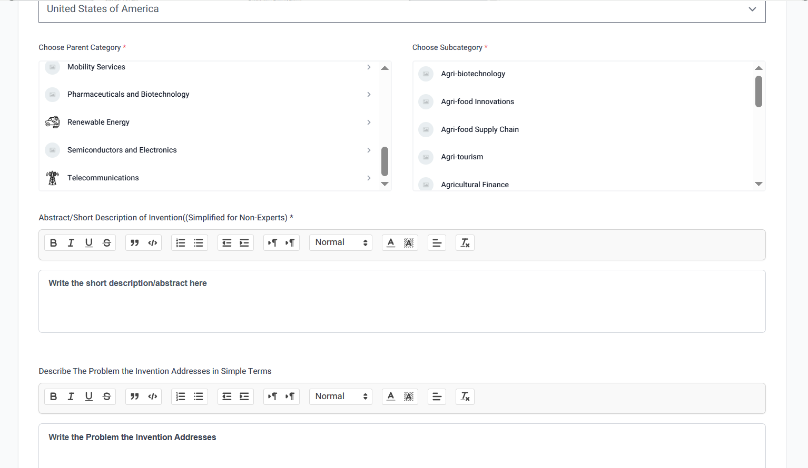

**And continue the further information related to patent as below and in the last click the save and continue to move to next step.**

Next, provide the further information related to your patent, such as detailed descriptions or summary. Once completed, click "Save and Continue" to move to the next step.

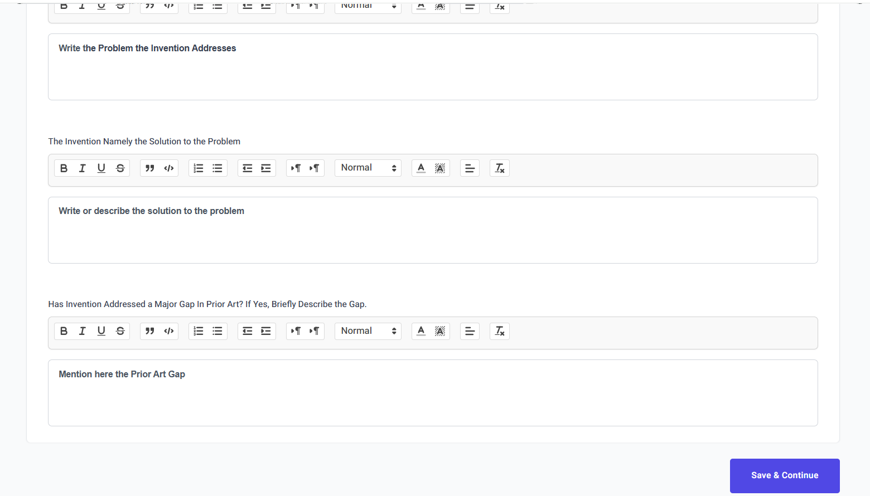

**Step 2 is here for further information of your patent to fill, which is mandatory and click save & continue for next step.**

Step 2: Fill in the mandatory further information about your patent, then click "Save & Continue" to proceed to the next step.

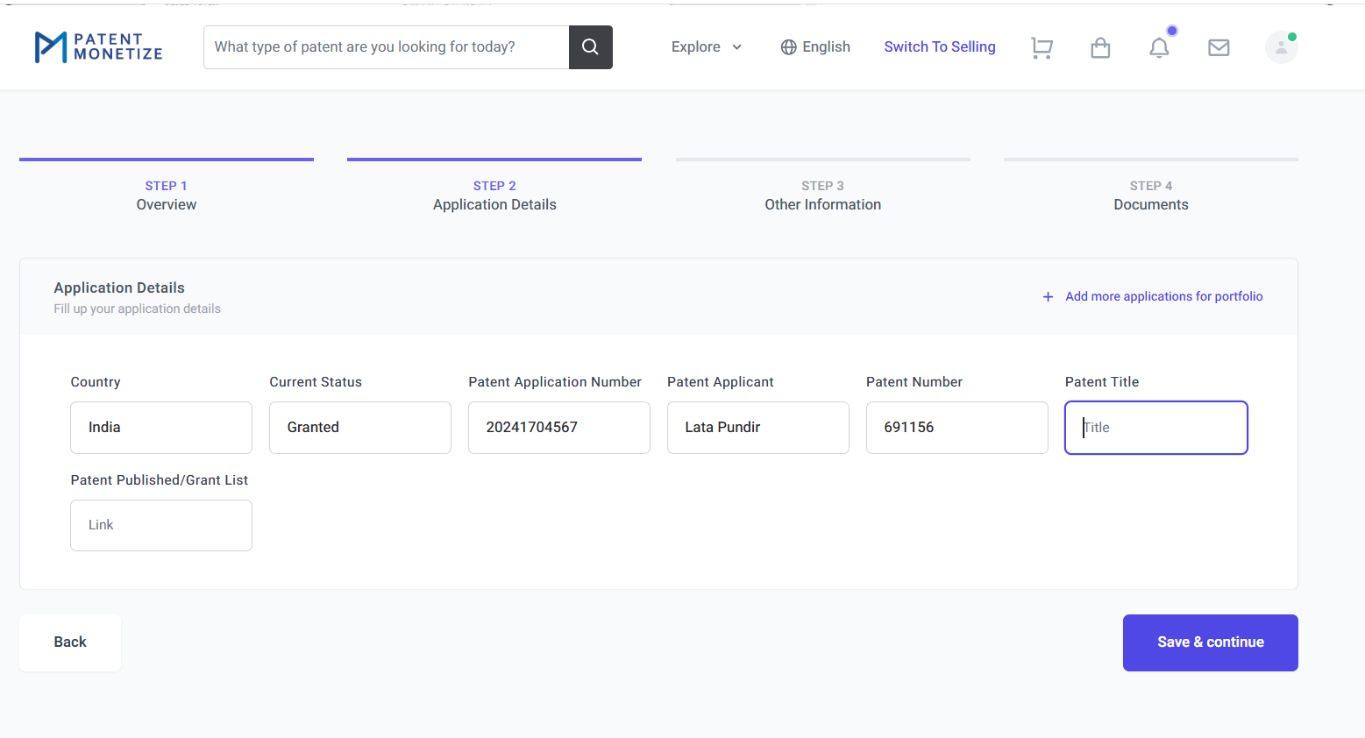

**Step 3 below are the step for process and product related information.**

Step 3: Below are the steps to fill in process and product-related information for your patent.

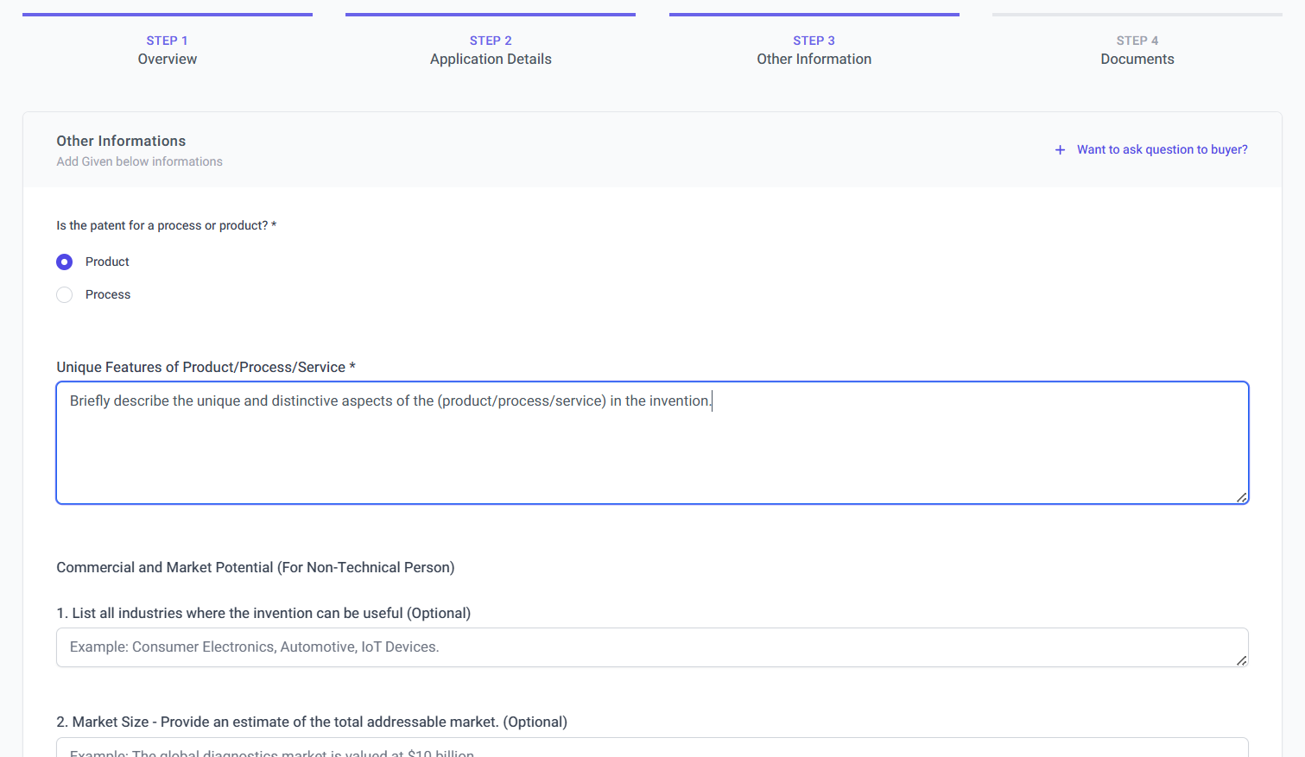

**Give your patent brief details which is optional with estimate and click save & continue for next step.**

Provide a brief description of your patent, which is optional, along with an estimated value, and then click "Save & Continue" to proceed to the next step.

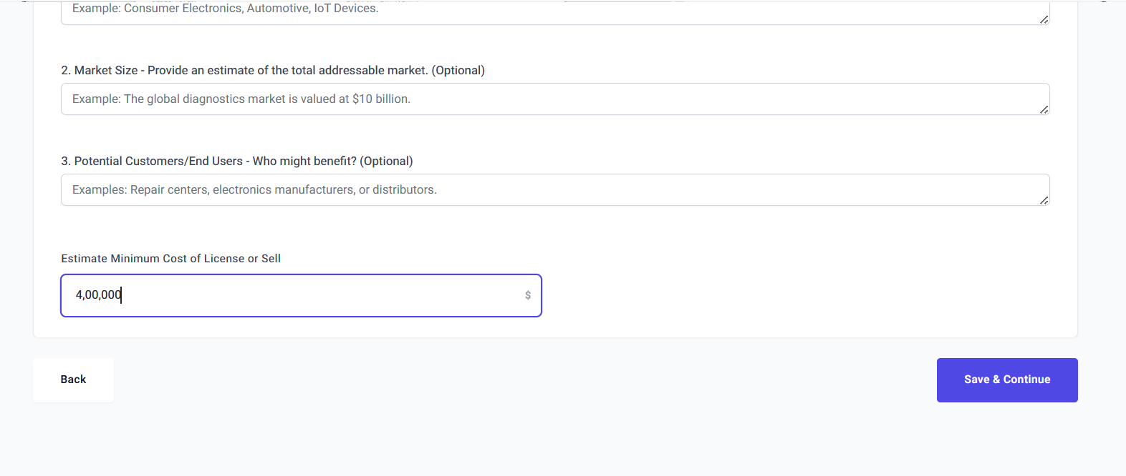

**Step 4 and last step to upload thumbnail and patent related images or video and then click to save & continue.**

Step 4: In the final step, upload a thumbnail, patent-related images, or a video, and then click "Save & Continue" to complete the listing process.

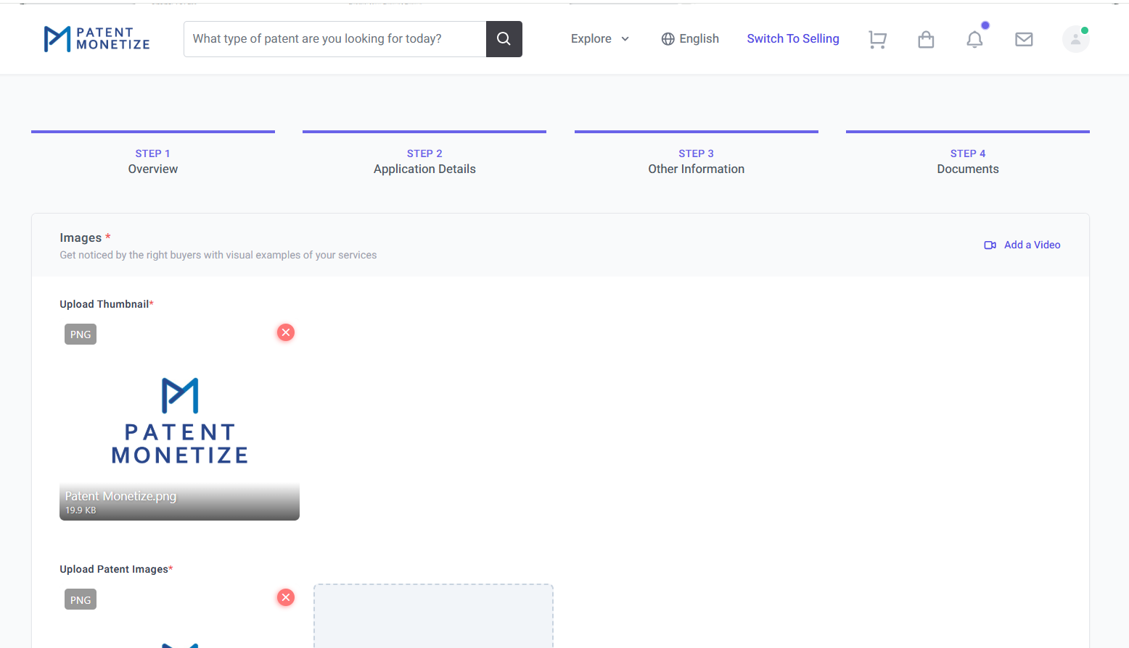

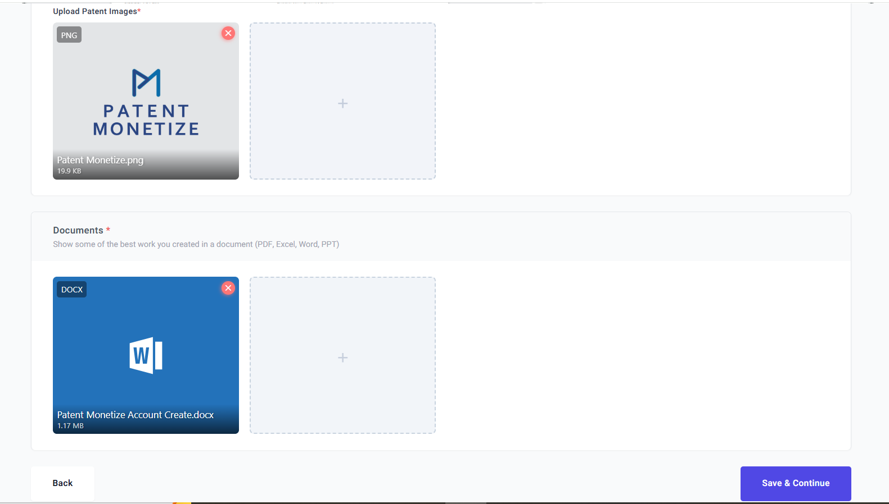

**Congratulation! Your patent has listed for selling.**

Congratulations! Your patent has been successfully listed.

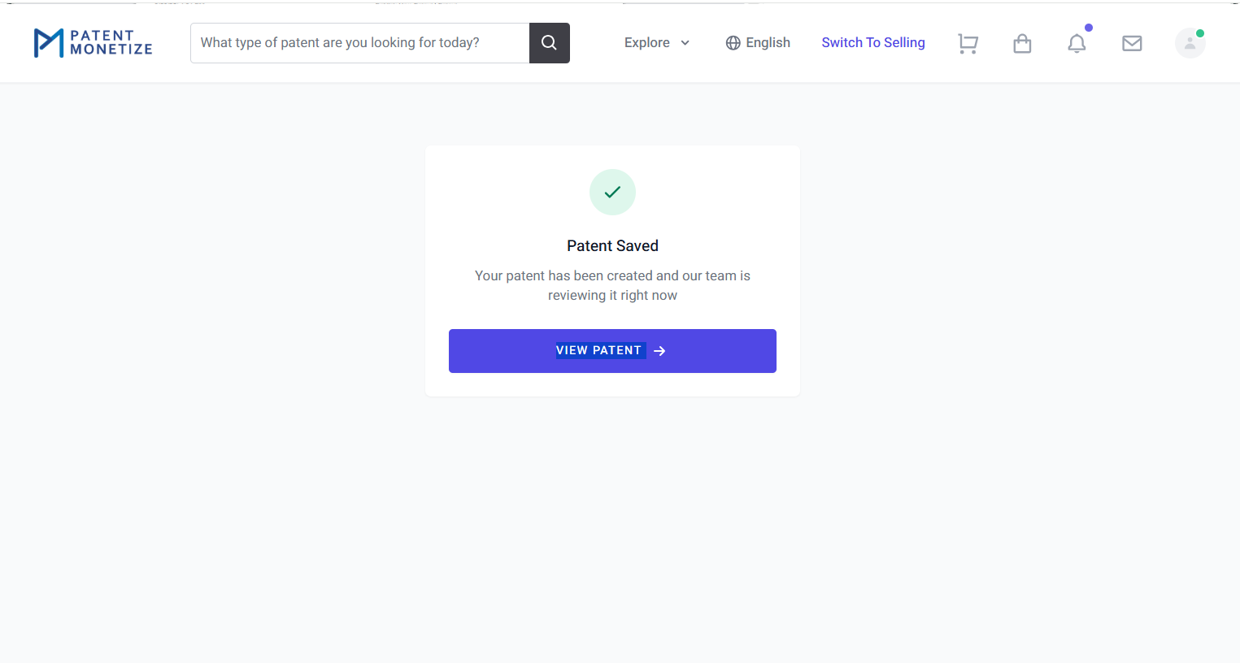

Once you will complete the listing. You will get the notification and review your patent listing.

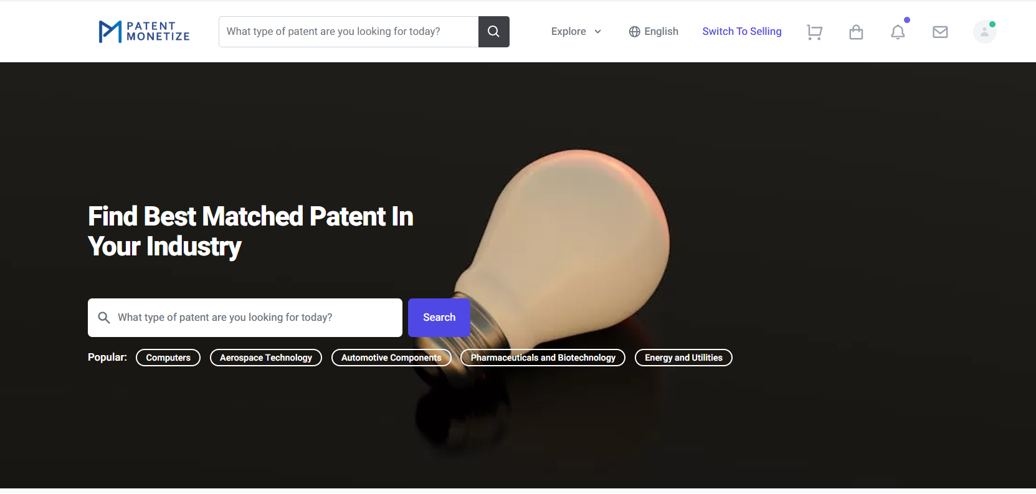

Here is the notification.

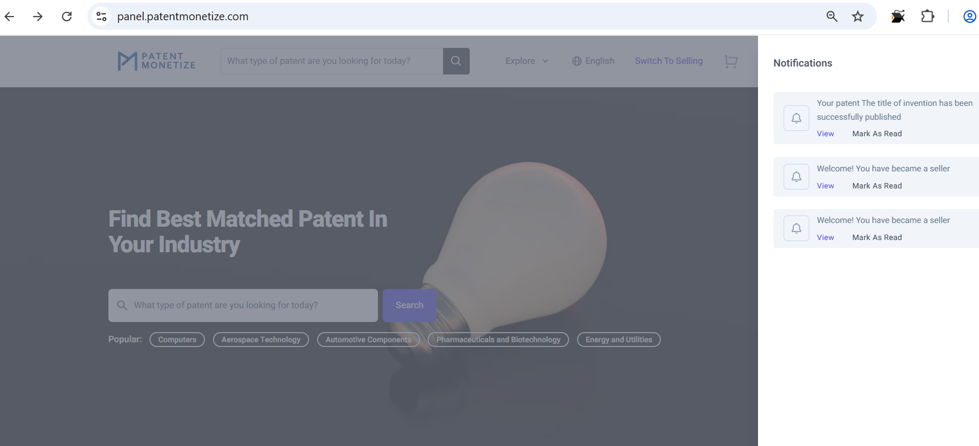

Review your listing patent

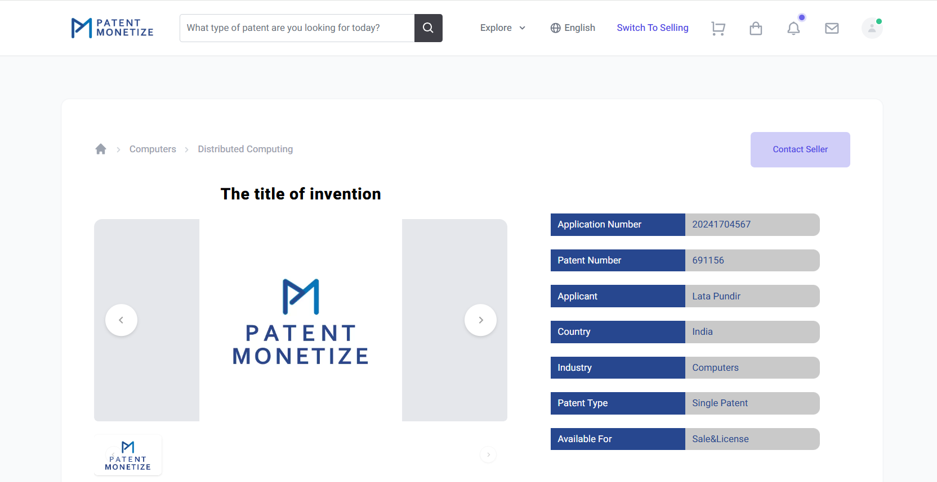

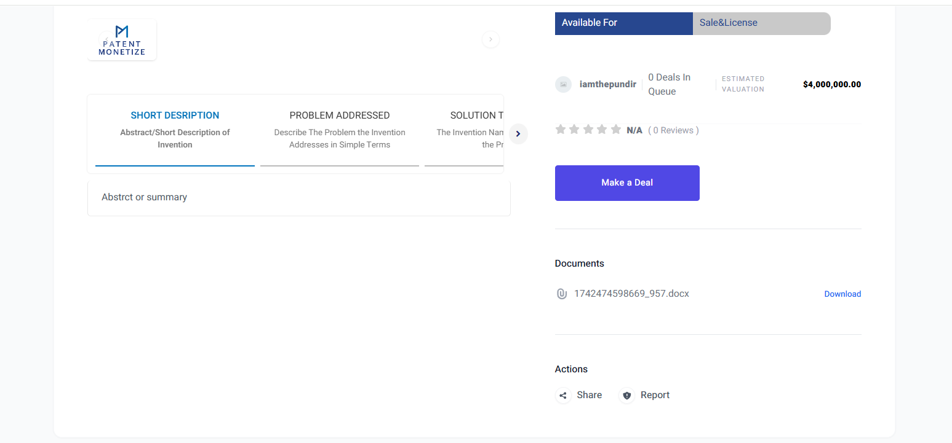

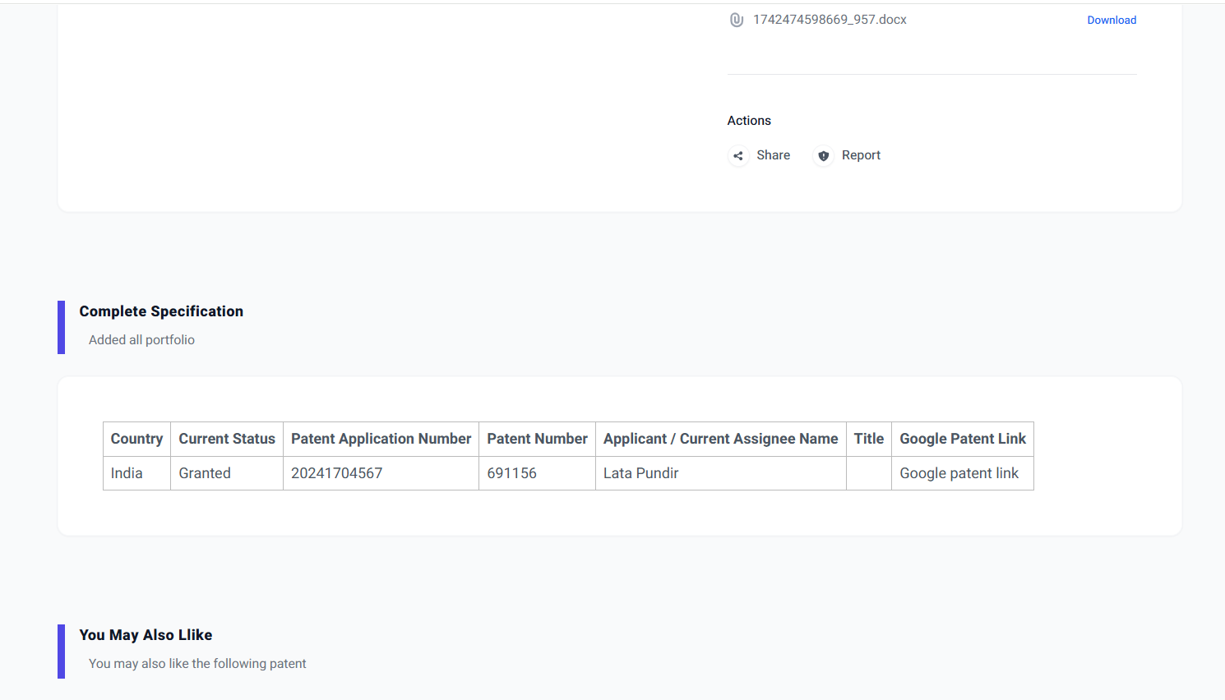

These are the details of your listing patent.

As seller se review your patent

